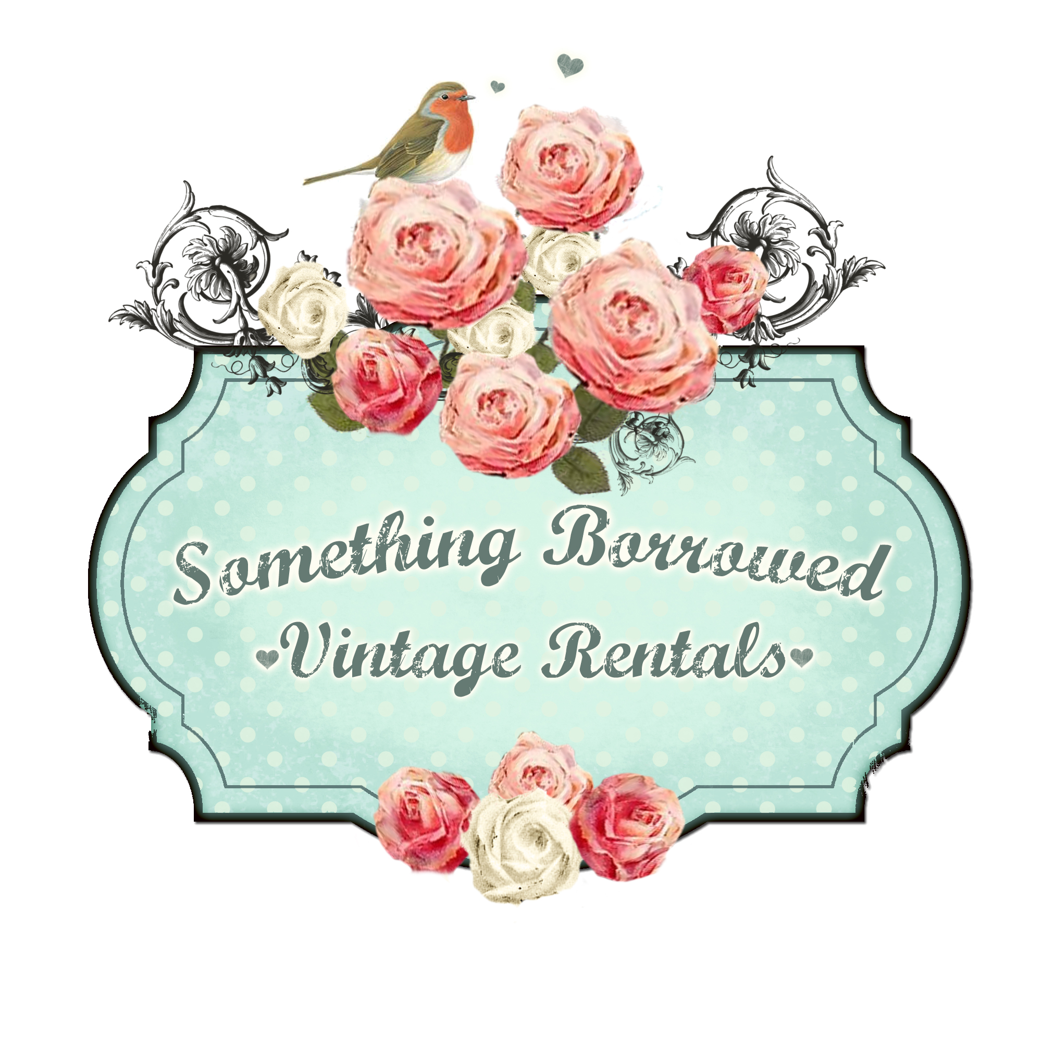

FAQ

Q. Do you have a price list?

A. There is a partial price list here at www.somethingborrowedvintagerentals.com but my inventory is too diverse to provide a comprehensive price list in one or two pages. In the event of discrepencies, the price listed on Facebook is the price that will be charged.
♥♥♥♥♥♥♥♥♥♥♥♥♥♥♥♥♥♥♥♥♥♥♥♥♥♥♥♥♥♥♥♥♥♥♥♥♥♥♥♥♥♥♥♥♥♥♥♥♥♥♥♥♥♥♥♥♥♥♥♥♥♥♥♥♥♥♥♥♥♥♥♥♥♥♥♥♥♥♥♥♥♥♥
Q. How do I find out the price on items then?

A. Go to Facebook, click on the icon "Photos" underneath the cover photo. Then click on the icon "Albums". Once you enter an album and click on an individual item there will be a description including dimensions if applicable, how many I have available and the rental price. The items are organized into categories with a separate album for each category.
♥♥♥♥♥♥♥♥♥♥♥♥♥♥♥♥♥♥♥♥♥♥♥♥♥♥♥♥♥♥♥♥♥♥♥♥♥♥♥♥♥♥♥♥♥♥♥♥♥♥♥♥♥♥♥♥♥♥♥♥♥♥♥♥♥♥♥♥♥♥♥♥♥♥♥♥♥♥♥♥♥♥♥
Q. Is the price per day?

A. No, it is per event.
♥♥♥♥♥♥♥♥♥♥♥♥♥♥♥♥♥♥♥♥♥♥♥♥♥♥♥♥♥♥♥♥♥♥♥♥♥♥♥♥♥♥♥♥♥♥♥♥♥♥♥♥♥♥♥♥♥♥♥♥♥♥♥♥♥♥♥♥♥♥♥♥♥♥♥♥♥♥♥♥♥♥♥
Q. What is the process to rent from Borrowed?

A. Send an email to sbvrent@gmail.com with:
(a) the date of the event
(b) your contact information - name, telephone number, mailing address; and
(c) a list of the items you are interested in renting
I will then check to make sure the items are available, prepare a rental agreement and invoice. I'll mail you two copies of the agreement together with a copy of the invoice (FYI only) and a self-addressed stamped envelope.You'll sign both copies of the agreement and return one copy to me with your deposit of 25% of the total invoice.
Once I receive the deposit, the items are reserved. The balance as well as a security deposit of approximately 10% of the replacement value of the items is due on pickup. The security deposit is returned once all my lovelies are back in the barn unharmed.
♥♥♥♥♥♥♥♥♥♥♥♥♥♥♥♥♥♥♥♥♥♥♥♥♥♥♥♥♥♥♥♥♥♥♥♥♥♥♥♥♥♥♥♥♥♥♥♥♥♥♥♥♥♥♥♥♥♥♥♥♥♥♥♥♥♥♥♥♥♥♥♥♥♥♥♥♥♥♥♥♥♥♥
Q. How long is the rental period?

A. The rental period is anywhere within the Thursday to Tuesday range for a weekend event. As long as I get the items back in time to prepare for the next weekends event
♥♥♥♥♥♥♥♥♥♥♥♥♥♥♥♥♥♥♥♥♥♥♥♥♥♥♥♥♥♥♥♥♥♥♥♥♥♥♥♥♥♥♥♥♥♥♥♥♥♥♥♥♥♥♥♥♥♥♥♥♥♥♥♥♥♥♥♥♥♥♥♥♥♥♥♥♥♥♥♥♥♥♥
Q. Do you deliver?

A. Currently I don't deliver - it is most cost effective for the borrower to pick up and return the items.
♥♥♥♥♥♥♥♥♥♥♥♥♥♥♥♥♥♥♥♥♥♥♥♥♥♥♥♥♥♥♥♥♥♥♥♥♥♥♥♥♥♥♥♥♥♥♥♥♥♥♥♥♥♥♥♥♥♥♥♥♥♥♥♥♥♥♥♥♥♥♥♥♥♥♥♥♥♥♥♥♥♥♥
Q. I live in PEI, NB, South Shore of NS, Yarmouth, etc. Do you rent items to my area?

A. You betcha! The rental period is long enough and flexible enough to allow the inventory to travel. And it has!
♥♥♥♥♥♥♥♥♥♥♥♥♥♥♥♥♥♥♥♥♥♥♥♥♥♥♥♥♥♥♥♥♥♥♥♥♥♥♥♥♥♥♥♥♥♥♥♥♥♥♥♥♥♥♥♥♥♥♥♥♥♥♥♥♥♥♥♥♥♥♥♥♥♥♥♥♥♥♥♥♥♥♥

